

International School

Capstone Project 1
CMU-SE 450

DATABASE DESIGN DOCUMENT
Clinic Booking
Clinic Booking and Management System using Chatbot and Voice Assistant

Submitted by: C1SE.62
Database Design Review Panel Representative:

Name: Signature Date

Capstone Project 1- Mentor:

Name: Msc.Nguyen Trung Thuan Signature Date

PROJECT INFORMATION

Project acronym | CB
Project Title | Clinic Booking
Start Date | September 6, 2024 | End Date | December 20,  2024
Lead Institution | International School, Duy Tan University
Project Mentor | Msc.Nguyen Trung Thuan
Scrum master  / Project Leader & contact details | Doan Hoang Quan  Email: quandoan.140203@gmail.com Tel: 0905413819  ID: 27211242264
Partner Organization
Project Web URL
Team members | Name | Email | Tel
27211248324 | Manh, Vo Van | vanmanh23012003@gmail.com | 0905118140
27211242264 | Quan, Doan Hoang | quandoan.140203@gmail.com | 0905413819
27211201526 | Lich, Huynh Ngoc | huynhngoclich10052003@gmail.com | 0935513362
26201241995 | Vy, Nguyen Yen | vyzit112002@gmail.com | 0775513141
27211221365 | Kien, Tran Trung | trantrungkien6@dtu.edu.vn | 0368313577

DOCUMENT APPROVALS
The following signatures are required for approval of this document.

Quan, Doan Hoang Student ID: 27211242264  Team Leader | Signature | Date
Manh, Van Vo  Student ID: 27211248324  Team Member | Signature | Date
Kien, Tran Trung Student ID: 27211221365  Team Member | Signature | Date
Vy, Nguyen Yen  Student ID: 26201241995  Team Member | Signature | Date
Lich, Huynh Ngoc Student ID: 27211201526  Team Member | Signature | Date

REVISION HISTORY

Version | Date | Comments | Author | Approval
1.0 | 3/10/2024 | Create Database Design | All member
1.1 | 3/11/2024 | Update Database Design | All member

TABLE OF CONTENT
- Introduction 5
  - Purpose 5
  - Scope 5
  - Introduction about MySQL 5
- Database Design 6
  - Table Overview 6
  - Entity Relationship Diagram 6
  - Table Relationship Diagram 7
  - Detail 7
- References 12

Figure
Figure 1. Entity Relationship Diagram 8
Figure 2. Table Relationship Diagram 8

Introduction
  - The Database Design maps the logical data model to the target database management system with consideration to the system’s performance requirements. The Database Design converts logical or conceptual data constructs to physical data constructs (e.g., tables...) of the target Database Management System.

Purpose
    - The purpose of the Database Design is to ensure that every database transaction meets or exceeds its performance requirements. This document takes into account data and transaction volume to produce a schema and environment that will meet necessary performance.

Scope
    - The Database Design Document has the following objectives:
- To describe the design of a database, that is, a collection of related data stored in one or more computerized files that can be accessed by users or developers via a DBMS.
- To serve as a basis for implementing the database and related software units. It provides the acquirer visibility into the design and provides information necessary for software development.

Introduction about MySQL
    - MySQL is an open-source relational database management system widely used for storing and managing data. It can be installed on various platforms such as Windows, Linux, and macOS. MySQL is one of the most popular database management systems in the world, thanks to its efficiency, reliability, and scalability.
    - MySQL uses Structured Query Language (SQL) to interact with data. It allows users to perform operations such as inserting, updating, deleting, and querying data easily. MySQL supports many advanced features like transactions, locking, and indexing, which help optimize performance and data security.
    - A table in MySQL is a data structure consisting of rows and columns, where each row represents a record and each column represents an attribute of that record
    - Data in MySQL is organized in tables, allowing for easy execution of JOIN operations to combine data from multiple tables. This helps optimize data storage and querying in complex applications.

Database Design

Table Overview

No. | Table name | Short Description
1 | Role | This table shows all information of Role.
2 | Users | This table shows all information of Users.
3 | Doctor | This table shows all information of Courts
4 | Departments | This table shows all information of Departments
5 | Time Slots | This table shows complete information about the time frames that can be booked
6 | Prescriptions | This table shows complete information about who has booked, which course and when
7 | DoctorRatings | This table shows all information of Invoices
8 | Medicines | This table shows yard photo information
9 | PatientRecords | This table shows all information of PatientRecords
10 | Appointments | This table shows all information of Appointments.
11 | ClinicInformation | This table shows all information of ClinicInformation.
12 | ChatbotResponses | This table shows all information of ChatbotResponses.

Entity Relationship Diagram
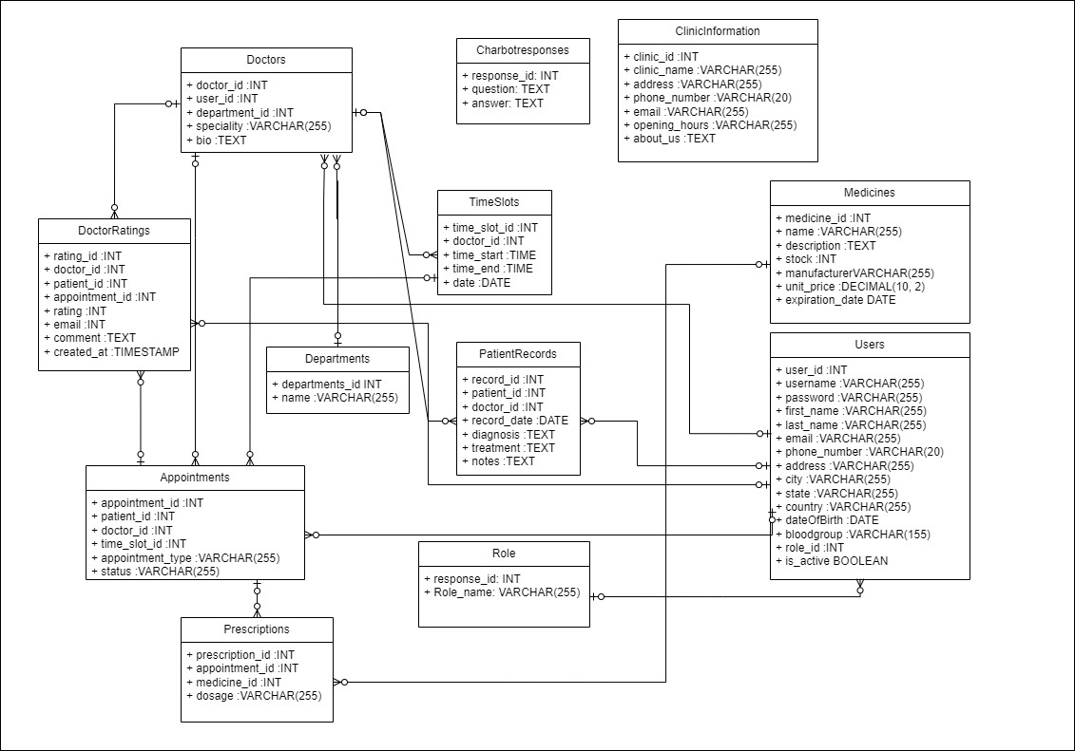

Figure 1. Entity Relationship Diagram

Table Relationship Diagram
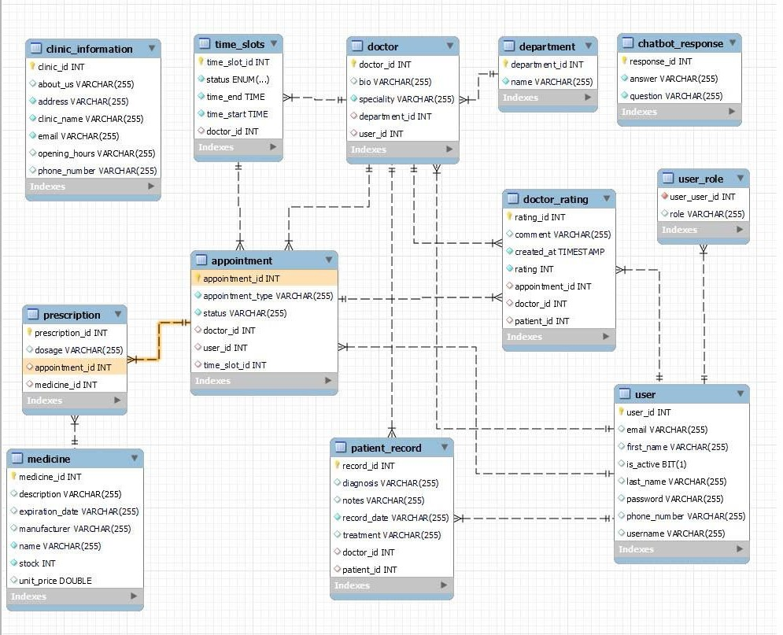

Detail
Figure 2. Table Relationship Diagram

    - Users
Attributes | Datatype | Null | Key | Default | Extra
user_id | INT | Not | PK | AUTO_INCR EMET
username | VARCHAR(255) | Not | UNIQUE | username
password | VARCHAR(255) | Not
first_name | VARCHAR(255)
last_name | VARCHAR(255)

email | VARCHAR(255) | Not | UNIQUE
phone_num ber | VARCHAR(20)
address | VARCHAR(255)
city | VARCHAR(255)
state | VARCHAR(255)
country | VARCHAR(255)
dateOfBirth | DATE
bloodgroup | VARCHAR(255)
role_id | INT | Not | FK |  | References Roles(role_id)
is_active | BOOLEAN |  |  | TRUE

    - Roles

Attributes | Datatype | Null | Key | Default | Extra
role_id | INT | Not | PK | AUTO_INCR EMENT
role_name | VARCHAR(255) | Not
    - Doctors

Attributes | Datatype | Null | Key | Default | Extra
doctor_id | INT | Not | PK | AUTO_INCR EMENT
user_id | INT | Not | FK |  | References Users(user_id)
department  _id | INT | Not | FK |  | References Departments(d epartment_id)
speciality | VARCHAR(255) | Not
bio | TEXT

    - Appointments
Attributes | Datatype | Null | Key | Default | Extra
appointment  _id | INT | Not | PK | AUTO_INC REMENT
patient_id | INT | Not | FK |  | References Users(user_id)
doctor_id | INT | Not | FK |  | References Doctors(doctor  _id)
appointment  _date | DATE | Not
appointment  _time | TIME | Not
appointment  _type | VARCHAR(255) | Not
status | VARCHAR(255) | Not
    - PatientRecords
Attributes | Datatype | Null | Key | Default | Extra
record_id | INT | Not | PK | AUTO_INC REMENT
patient_id | INT | Not | FK |  | References Users(user_ id)
doctor_id | INT | Not | FK |  | References Doctors(do ctor_id)
record_date | DATE | Not
diagnosis | TEXT
treatment | TEXT
notes | TEXT

    - ClinicInformation
Attributes | Datatype | Null | Key | Default | Extra
clinic_id | INT | Not | PK | AUTO_IN CREMENT
clinic_name | VARCHAR(255) | Not
address | VARCHAR(255) | Not
phone_number | VARCHAR(20)
email | VARCHAR(255) | Not
opening_hours | VARCHAR(255)
about_us | TEXT
    - ChatbotResponses

Attributes | Datatype | Null | Key | Default | Extra
response_id | INT | Not | PK | AUTO_IN CREMEN T
question | TEXT | Not
answer | TEXT | Not
    - Medicines

Attributes | Datatype | Null | Key | Default | Extra
medicine_id | INT | Not | PK | AUTO_IN CREMEN T
name | VARCHAR(255) | Not
description | TEXT
stock | INT | Not
manufacturer | VARCHAR(255)

unit_price | DECIMAL(10, 2)
expiration_ date | DATE

    - Departments

Attributes | Datatype | Null | Key | Default | Extra
department_id | INT | Not | PK | AUTO_INCR EMENT
name | VARCHAR(255) | Not
    - Prescriptions

Attributes | Datatype | Null | Key | Default | Extra
prescription_id | INT | Not | PK | AUTO_INCR EMENT
appointment_id | INT | Not | FK |  | References Appointments( appointment_i d)
medicine_id | INT | Not | FK |  | References Medicines(me dicine_id)
dosage | VARCHAR(255)
prescription_ id | INT | Not | PK | AUTO_INCR EMENT
    - TimeSlots

Attributes | Datatype | Null | Key | Default | Extra
time_slots_id | INT | Not | PK | AUTO_INCR EMENT

time_start | TIME | Not
time_end | TIME | Not
status | VARCHAR(255) | Not
doctor_id | INT | Not | FK |  | References Doctor(doctor_i d)

References
- https://www.w3schools.com/mysql/mysql_datatypes.asp
- https://dev.mysql.com/doc/refman/8.0/en/data-types.html

